ABSTRACT
The aim of this application is to deliver information to any individual who is keen to know about the details of his college/institute which is unavailable on the general college/institute website. This application stores all the information in the form of pages and can be easily be accessed by any user who is visiting the website. One more element that makes this web application much interesting is that the information about any page can be entered by any registered user and even the edit history of the pages can be viewed and edited dynamically.

PROBLEM DEFINITION
The lack of information flow in the environment leads to misunderstandings. To bridge this gap there needs to be a robust solution that connects the information together. Our aim with this web application is to collect and display as much as information possible to any user who is requesting data.

Design
1. Introduction
College Wikipedia is a web application which stores the information of the college staff and users can view as well as edit the details. Our web application is hosted on Appspot, and uses Python’s webapp2 framework for its backend purposes. The frontend uses HTML5, CSS3 and Jinja2 template for rendering the HTML pages.

2. Limitation of the application
Our web application may not give results initially when the data for the particular element is not entered previously, it implies that at initial stage, the data needs to be added into the pages and can be from anonymous users.

3. About the project
The objective of the project is to build a web application that is accessible by any client particularly who need to know the details of the college staff.
The features of the application are:
- User input for the data filling.
- Store the data for the clients.
- Accessing as well as editing the data generated by the user.

- Home Page
Below is a screenshot of the home page of our application:
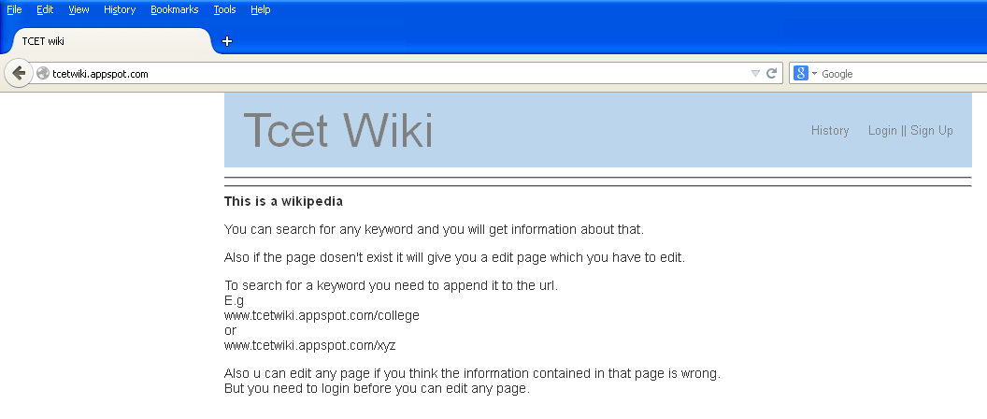
URL Link: www.tcetwiki.appspot.com
Purpose: You can search for any keyword and you will get information about that.
Also if the page dosen't exists it will give you an edit page which you have to edit.
To search for a keyword you need to append it to the url.
E.g
www.tcetwiki.appspot.com/college
or
www.tcetwiki.appspot.com/xyz
Also u can edit any page if you think the information contained in that page is wrong.
But you need to login before you can edit any page.
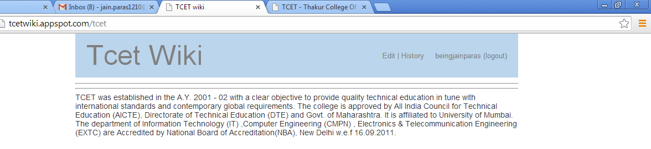



- User login form.
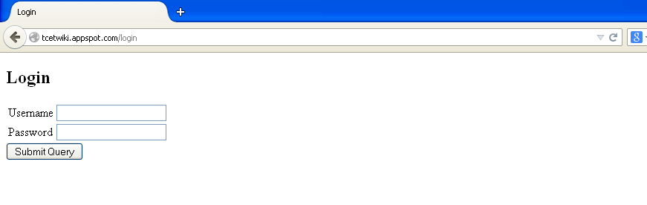
This is a login page for the user.

- Storing the form values in the database
Our application stores each source and destination entry in the Google App Engine datastore. Each entry in our database is also assigned a system generated key at the time of storage. Here’s a screenshot of what our database looks like:
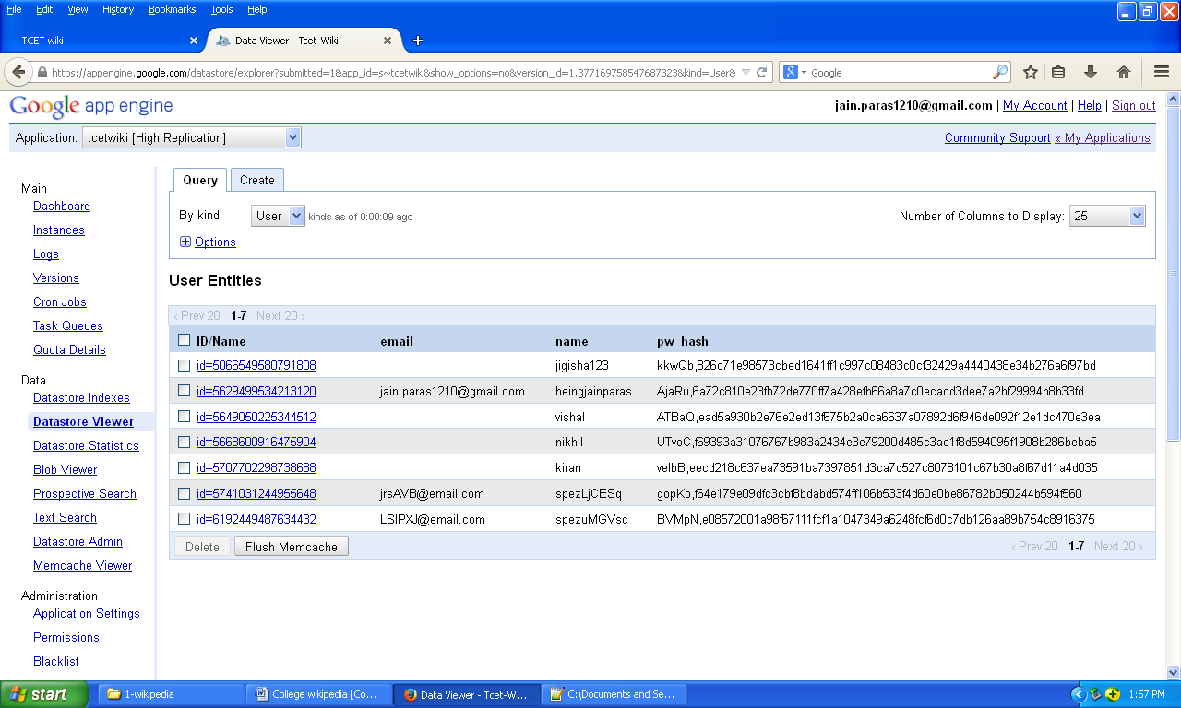
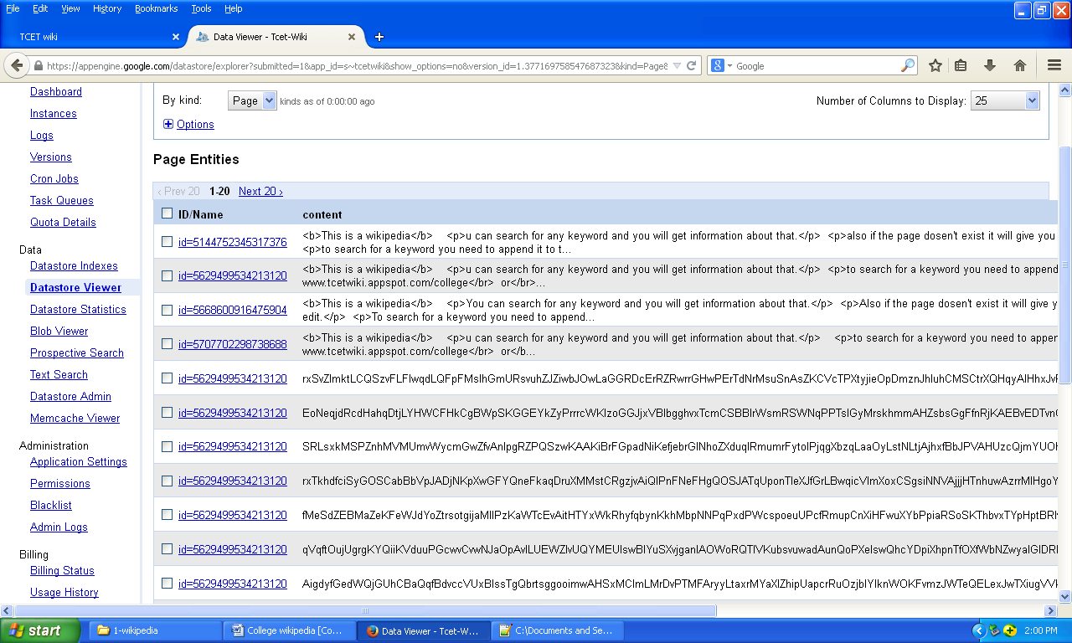

- Implementation steps

Code:
The main Python code for our application is as follows:

import os
import os.path
import re
import random
import hashlib
import hmac
import logging
import json
from datetime import datetime, timedelta
from string import letters
import webapp2
import jinja2
from google.appengine.api import memcache
from google.appengine.ext import db

template_dir = os.path.join(os.path.dirname(__file__),'templates')
jinja_env = jinja2.Environment(loader = jinja2.FileSystemLoader(template_dir),autoescape = True)
secret='beingjainparas'

DEBUG = bool(os.environ['SERVER_SOFTWARE'].startswith('Development'))
if DEBUG:
logging.getLogger().setLevel(logging.DEBUG)

def render_str(template,**params):
t=jinja_env.get_template(template)
return t.render(params)

def make_secure_val(val):
return '%s|%s' % (val,hmac.new(secret,val).hexdigest())

def check_secure_val(secure_val):
val=secure_val.split('|')[0]
if secure_val == make_secure_val(val):
return val

def gray_style(lst):
for n,x in enumerate(lst):
if n % 2 == 0:
yield x,''
else:
yield x, 'gray'

class Handler(webapp2.RequestHandler):
def write(self, *a, **kw):
self.response.out.write(*a, **kw)
def render_str(self,template,**params):
params['user'] = self.user
params['gray_style'] = gray_style
return render_str(template,**params)
def render(self,template,**kw):
self.write(self.render_str(template,**kw))
def render_json(self,d):
json_txt = json.dumps(d)
self.response.headers['Content-Type'] = 'application/json; charset=UTF-8'
self.write(json_txt)
def set_secure_cookie(self,name,val):
cookie_val = make_secure_val(val)
self.response.headers.add_header('Set-Cookie','%s=%s; Path=/' % (name,cookie_val))
def read_secure_cookie(self,name):
cookie_val = self.request.cookies.get(name)
return cookie_val and check_secure_val(cookie_val)
def login(self,user):
self.set_secure_cookie('user_id', str(user.key().id()))
def logout(self):
self.response.headers.add_header('Set-Cookie','user_id=; Path=/')
def initialize(self,*a,**kw):
webapp2.RequestHandler.initialize(self,*a,**kw)
uid = self.read_secure_cookie('user_id')
self.user = uid and User.by_id(int(uid))
self.can_post = self.user and self.user.name == 'spez'
if self.request.url.endswith('.json'):
self.format = 'json'
else:
self.format = 'html'
def notfound(self):
self.error(404)
self.write('<h1>404: Not Found</h1>Sorry my friend but the page does not exist.')

def make_salt(length = 5):
return ''.join(random.choice(letters) for x in xrange(length))

def make_pw_hash(name, pw, salt = None):
if not salt:
salt = make_salt()
h = hashlib.sha256(name + pw + salt).hexdigest()
return '%s,%s' % (salt, h)

def valid_pw(name, password, h):
salt = h.split(',')[0]
return h == make_pw_hash(name, password, salt)

def users_key(group = 'default'):
return db.Key.from_path('users', group)

class User(db.Model):
name = db.StringProperty(required = True)
pw_hash = db.StringProperty(required = True)
email = db.StringProperty()
@classmethod
def by_id(cls, uid):
return User.get_by_id(uid, parent = users_key())
@classmethod
def by_name(cls, name):
u = User.all().filter('name =', name).get()
return u
@classmethod
def register(cls, name, pw, email = None):
pw_hash = make_pw_hash(name, pw)
return User(parent = users_key(),name = name,pw_hash = pw_hash,email = email)
@classmethod
def login(cls, name, pw):
u = cls.by_name(name)
if u and valid_pw(name, pw, u.pw_hash):
return u

USER_RE = re.compile(r"^[a-zA-Z0-9_-]{3,20}$")
def valid_username(username):
return username and USER_RE.match(username)
PASS_RE = re.compile(r"^.{3,20}$")
def valid_password(password):
return password and PASS_RE.match(password)
EMAIL_RE = re.compile(r'^[\S]+@[\S]+\.[\S]+$')
def valid_email(email):
return not email or EMAIL_RE.match(email)

class Signup(Handler):
def get(self):
next_url = self.request.headers.get('referer','/')
self.render("signup-form.html", next_url = next_url)
def post(self):
have_error = False

next_url = str(self.request.get('next_url'))
if not next_url or next_url.startswith('/login'):
next_url='/'

self.username = self.request.get('username')
self.password = self.request.get('password')
self.verify = self.request.get('verify')
self.email = self.request.get('email')
params = dict(username = self.username,email = self.email)
if not valid_username(self.username):
params['error_username'] = "That's not a valid username."
have_error = True
if not valid_password(self.password):
params['error_password'] = "That wasn't a valid password."
have_error = True
elif self.password != self.verify:
params['error_verify'] = "Your passwords didn't match."
have_error = True
if not valid_email(self.email):
params['error_email'] = "That's not a valid email."
have_error = True
if have_error:
self.render('signup-form.html', **params)
else:
self.done()
def done(self, *a, **kw):
raise NotImplementedError

class Register(Signup):
def done(self):
#make sure the user doesn't already exist
next_url = str(self.request.get('next_url'))
u = User.by_name(self.username)
if u:
msg = 'That user already exists.'
self.render('signup-form.html', error_username = msg)
else:
u = User.register(self.username, self.password, self.email)
u.put()
self.login(u)
self.redirect(next_url)

class Login(Handler):
def get(self):
next_url = self.request.headers.get('referer','/')
self.render('login-form.html', next_url = next_url)
def post(self):
username = self.request.get('username')
password = self.request.get('password')

next_url = str(self.request.get('next_url'))
if not next_url or next_url.startswith('/login'):
next_url='/'

u = User.login(username, password)
if u:
self.login(u)
self.redirect(next_url)
else:
msg = 'Invalid login'
self.render('login-form.html', error = msg)

class Logout(Handler):
def get(self):
next_url = self.request.headers.get('referer','/')
self.logout()
self.redirect(next_url)

class Page(db.Model):
content= db.TextProperty()
#author = db.RefrenceProperty(User, required = True)
created = db.DateTimeProperty(auto_now_add = True)
last_modified = db.DateTimeProperty(auto_now = True)

@staticmethod
def parent_key(path):
return db.Key.from_path('/root'+path,'pages')

@classmethod
def by_path(cls,path):
q=cls.all()
q.ancestor(cls.parent_key(path))
q.order("-created")
return q

@classmethod
def by_id(cls,page_id,path):
return cls.get_by_id(page_id,cls.parent_key(path))

class NoSlash(Handler):
def get(self,path):
new_path = path.rstrip('/') or '/'
self.redirect(new_path)

class EditPage(Handler):
def get(self,path):
if not self.user:
self.redirect('/login')

v=self.request.get('v')
p=None
if v:
if v.isdigit():
p=Page.by_id(int(v),path)

if not p:
return self.notfound()
else:
p=Page.by_path(path).get()

self.render("edit.html", path=path,page=p)

def post(self,path):
if not self.user:
self.error(400)
return

content=self.request.get('content')
old_page = Page.by_path(path).get()
if not (old_page or content):
return
elif not old_page or old_page.content != content:
p= Page(parent=Page.parent_key(path), content = content)
p.put()
self.redirect(path)
class HistoryPage(Handler):
def get(self,path):
q=Page.by_path(path)
q.fetch(limit=100)

posts = list(q)
if posts:
self.render("history.html", path=path, posts=posts)
else:
self.redirect("/_edit" +path)

class WikiPage(Handler):
def get(self,path):
v=self.request.get('v')
p=None
if v:
if v.isdigit():
p=Page.by_id(int(v),path)

if not p:
return self.notfound()
else:
p=Page.by_path(path).get()
if p:
self.render("page.html", page= p, path = path)
else:
self.redirect("/_edit" + path)
PAGE_RE = r'(/(?:[a-zA-Z0-9_-]+/?)*)'
app = webapp2.WSGIApplication([('/signup',Register),
('/login',Login),
('/logout',Logout),
#('((/.*/+)',NoSlash),
('/_history' + PAGE_RE,HistoryPage),
('/_edit' + PAGE_RE,EditPage),
(PAGE_RE,WikiPage),
],
debug=DEBUG)

Conclusion

The following activities are Complete:
- Solution Design
- Installation of Software
- Database Setup
- Code Development
- Testing
- Release for review
- Hardware requirement
To be able to use the system has to there needs to be a browser to view the pages . The solution will be running on the web server and the user will need to view the page using the browser. The technical requirements for this hardware interface mentioned below.
The minimum requirements of hardware to run this system are as follows—
- Basic Internet Connection.
- 256 MB Ram
- Internet Browser.
- Standard keyboard and other device to process the input.
8. software requirements
The data that will be deployed on the system will be coming from Google Maps API and Google App Engine. The database of the data server is built using Google App Engine datastore. The In short, this is a three-tier solution.
At a glance,

- Operating system- Windows XP Professional and higher.
- Color monitor—Screen resolution from 800X600
- Application: Google Maps API (It provides us with the data including the distances from one place to another and so on)
- Google App Engine : It is a Google infrastructure which allows the hosting of local files onto its own server infrastructure.
- Webapp2 framework : It is a Python based framework used to build scalable and dynamic web applications.
System will peacefully co-exist with any windows supported software
Google app engine datastore: It is Google App Engine’s inbuilt database system.

References
- www.udacity.com/cs101/intro-to-cmp-science/
- www.udacity.com/cs253
- https://appengine.google.com/

